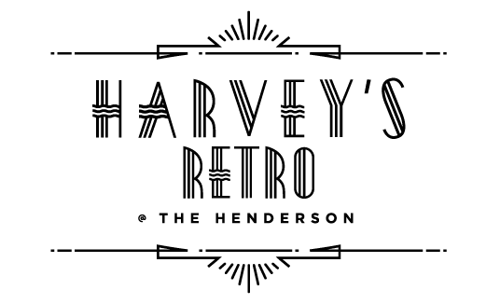



DINNER

**COOL & CRISP**

12**

Smoke, Sriracha, Blue Cheese Powder

**Panko Crusted Goat Cheese Salad** **16**

Roasted Beets, Cranberries**,**

ToastedHazelnut Vinaigrette

**The Henderson Caprese**  ** 14**

Bocconcini, Tomatoes, Herb Oil,

Strawberry-Balsamic Reduction

**Jumbo NC Shrimp Cocktail** ** 16**

Tomato-Horseradish Sauce, Wakame Salad

**Salade Niçoise  ** **18*\****

Everything Crusted Ahi Tuna, Egg, Olives

Green Beans, Tomatoes, Sherry Vinaigrette

**Charcuterie & Artisanal Cheeses** **24**

NC Hickory Nut Gap Farm Salami & Sopressata Homemade Fig Jam, House Cultivated Honeycomb,

Cornichons, Crostini’s **GFO**

***Vegetarian & Vegan options available* **

***\*Consuming raw or undercooked meats, poultry, seafood, shellfish, or eggs may increase your risk of foodborne illness***

**BOLD & WARM**

**French Onion Soup 12**

Brioche Crouton, Gruyère Cheese

**Oven Roasted Sea Scallops**  **22**

Lemon & Chive Butter, Toasted Brioche

**Baked Brie en Croûte****14**

Wild Berry &Jalapeño Jam,

French Bread Crostini’s

**Escargots à la Bourguignonne 14**

Garlic-Parsley Butter, Toast Points

**Pan Seared Foie Gras 22**

Apple Bread Pudding, Caramelized Figs, Calvados Reduction

**NC Shrimp & Crab Crêpes Thermidor**  **18**

Tarragon, Tomatoes, Cognac, Parmesan

**PAELLA**

*Our Paellas are made with Bomba Rice,*

*Sofrito and Saffron Broth*

*Entire pans of paella are prepared to order and*

*presented tableside*

*Please allow up to 30 minutes of preparation time*

**Paella Valenciana **  **28 *per person***

NC Shrimp, PEI Mussels, Chicken, Spanish Chorizo

**Vegetarian/Vegan****22 *per person***

Farmers Market Seasonal Vegetables

**ROBUST & SAVORY**

**Traditional British Fish & Chips **  **24**

Beer Battered Cod, Twice Cooked Russet Potatoes, Homemade Tartar Sauce

**Pan Seared NC Mountain Trout**  **24**

Fall Leaves, Crispy Onions, Teardrop Tomatoes, Lemon-Pepper Vinaigrette

**Pork Wellington**  **26**

Mushroom Duxelle, Prosciutto, Puff Pastry,

Gratin Dauphinoise, Julienne Vegetables, Demi-Glacé

**Bœuf Bourgignon  28**

Red Wine, Mushrooms, Pearl Onions,

Roasted Root Vegetables, Mashed Potatoes

**Free Range Chicken Breast ‘Puttanesca’** **24**

Roma Tomatoes, Garlic, Olives, Anchovies,

Fresh Linguini

**Zucchini ‘Ravioli’**    **20**

Ricotta, Spinach, Basil, Mozzarella Cheese, Fresh Tomato Sauce

 Gluten FreeLactose Free Spicy

 Pescatarian Vegetarian  Vegan

**GFO** Gluten Free Available