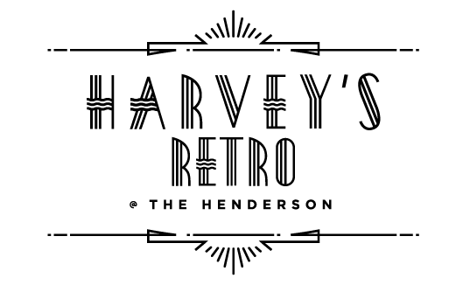

DESSERTS

**SWEET & SINFUL** **12**

**Key Lime Pie Cheesecake**

Fresh Strawberries

**

Caramelized Sugar

**Molten Valrhona Chocolate Cake**

Cookies & Cream Ice Cream

**Butterscotch & Chocolate Chip**

**Bread Pudding**

Vanilla Ice Cream



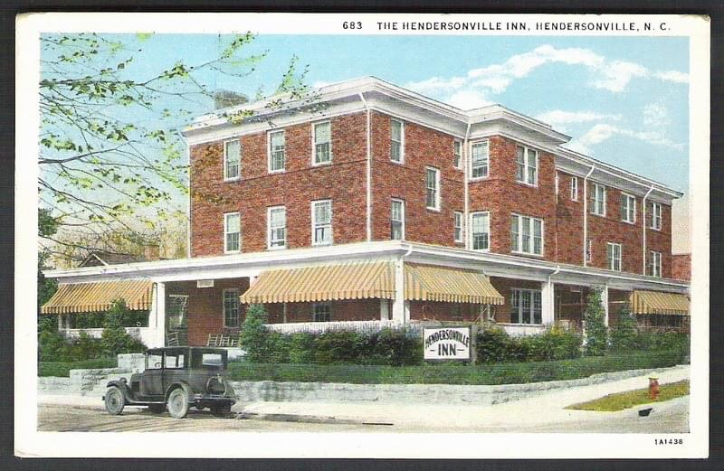

**PRIVATE PARTIES**

**Harvey’s @ The Henderson is the perfect venue for private parties of 20-40 people in a historic and intimate setting.**

**Have your rehearsal dinners, baby & bridal showers, and family get-togethers here at Harvey’s @ The Henderson.**

**Our event menus are customized to fit our guests’ dietary needs and budget requirements.**

**Please feel free to set up an appointment to discuss your needs further.**

**Visit our website for more details or call (828) 696 2001**

**TheHendersonNC.com/harveys/**



**PRIVATE PARTIES**

**Harvey’s @ The Henderson is the perfect venue for private parties of 20-40 people in a historic and intimate setting.**

**Have your rehearsal dinners, baby & bridal showers, and family get-togethers here at Harvey’s @ The Henderson.**

**Our event menus are customized to fit our guests’ dietary needs and budget requirements.**

**Please feel free to set up an appointment to discuss your needs further.**

**Visit our website for more details or call (828) 696 2001**

**TheHendersonNC.com/harveys/**



DESSERTS

**SWEET & SINFUL** **12**

**Key Lime Pie Cheesecake**

Fresh Strawberries

**

Caramelized Sugar

**Molten Valrhona Chocolate Cake**

Cookies & Cream Ice Cream

**Butterscotch & Chocolate Chip**

**Bread Pudding**

Vanilla Ice Cream

