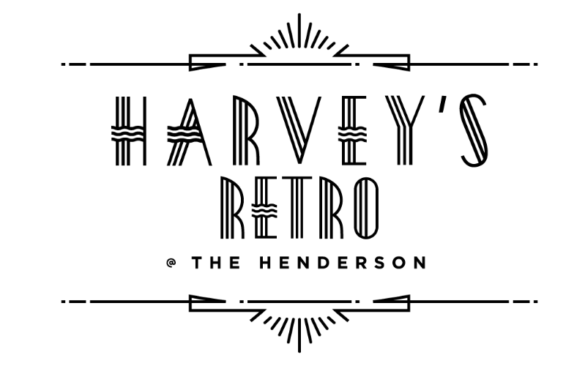



LIQUID LIBATIONS

*“Fill your life with friends and your glass with wine”*

**COCKTAILERY & TOM FOOLERY 12**

**Harvey’s Martini |** NC Conniption Gin,

Dry Vermouth, Caper Berries

**Myrtle Mae |**Tito’s Vodka, Cointreau, Pomegranate Juice, Fresh Lemon & Lime

**Gin Rickey |**Beefeater Gin, Fresh Lime Juice,

Soda Water

**Spiced Old Fashioned |**NC Spiced Rum, Orange & Angostura Bitters, Amarena Cherry Mash

**Nutty Irishman |**Stoli Vanilla, Frangelico,

Irish Cream, Nutmeg

**Negroni |**Campari, NC Conniption Gin,

Sweet Vermouth

**Hemingway Daiquiri |**Bacardi Rum, Luxardo,

Fresh Grapefruit Juice

**Paloma |** Tequila, Amaro Liqueur,

Fresh Lime & Grapefruit Juices

**Classic Cosmopolitan |**Absolut Citron, Cointreau, Cranberry Juice, Fresh Lime

**Manhattan |**Bulleit Rye, Sweet Vermouth, Angostura Bitters

**Old Fashioned |**Bourbon, Angostura Bitters, Orange & Amarena Cherry Mash

**MOCKTAILS & DREAMS 12**

**Zero Fashioned |**NABourbon, Bitters,

Orange & Amarena Cherry Mash

**Tommy Collins |** NA Gin, Fresh Lemon Juice,

Homemade Syrup, Soda Water

**Traditional Daiquiri |** Fleur NA Rum, Orange Simple Syrup, Fresh Lime Juice

**Pom Margarita |** NA Mezcal, NA Triple Sec, Pom, Fresh Lime Juice

**Alfie |**NAGin, Triple Sec, Fresh Lemon,

Homemade Syrup

**BARLEY & BREWS 6**

Sierra Nevada Pale Ale

Hazy Little Thing IPA

Armed Forces Lager

Foothills Torch Pilsner

Sam Adams – ‘Just the Haze’ IPA (**Alcohol Free**)

**BUBBLES**

**Riondo,** Prosecco | Italy **10/ 36**

**Freixenet NA,** Brut Cava | Spain **10/ 36**

(**Alcohol Free**)

**BOTTLE SPECIALS**

**Markstone,** Cabernet, 2022| California **30**

**Markstone,** Pinot Noir, 2022 | California **30**

**Markstone,** Chardonnay, 2022 | California **30**

**Markstone,** Pinot Grigio, 2022 | California **30**

**Tomaiolo,** Chianti Classico, 2021 | Tuscany **30**

**Hindsight,** Sauvignon Blanc, 2020 | Napa **35**

**Browne Forest Project,** Cabernet, 2021 | Paso Robles **35**

**WHITES**

**Benvolio,** Pinot Grigio 2022| Italy **10/ 35**

**Kendall Jackson,** Vintner’s Reserve, Chardonnay, 2020 | California **12/ 36**

**Matua,** Sauvignon Blanc, 2022 | Marlborough,

New Zealand **12/ 36**

**Sokol Blosser,** Evolution # 9, White Blend 2021 |Oregon **12/ 36**

**Vila Nova,** Vinho Verde 2023| Portugal **35**

**Cordillera Reserva,** Chardonnay, 2022 | Chile **40**

**Menade Verdejo Organic,** 2023 | Spain **40**

**Castillo de Maetierra,** Albarino, 2023 | Spain **45**

**Giesen,** Sauvignon Blanc | New Zealand **10/35** (**Alcohol Free**)

**ROSE**

**Oko** |France, 2022 **12/ 36**

**Elicio** |France **12/ 36**

**REDS**

**Coppola,** Cabernet, 2021|Paso Robles **12/ 36**

**Coppola,** Pinot Noir, 2021| Monterey **12/ 36**

**Luminare,** Red Blend | Napa, CA **35** (**Alcohol Free**)

**Barista,** Pinotage, 2023| South Africa **12/ 36**

**Bodegas Lattue,** Tempranillo, 2022| Spain **40**

**Escudo Rojo,** Syrah Gran Reserve, 2022| Chile **45**

**Heritage,** Pinot Noir, 2021| Willamette Valley **50**

**Educated Guess,** Cabernet, 2021 | CA **50**

**WINE OF THE MONTH**

**Sartori di Verona**

**Love Story, Pinot Noir, Italy 2019**

**30**