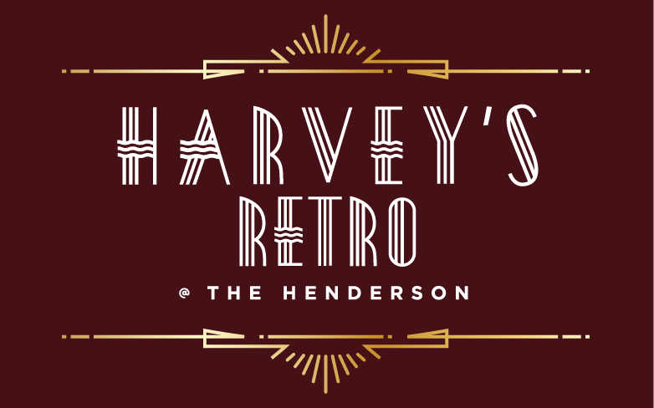

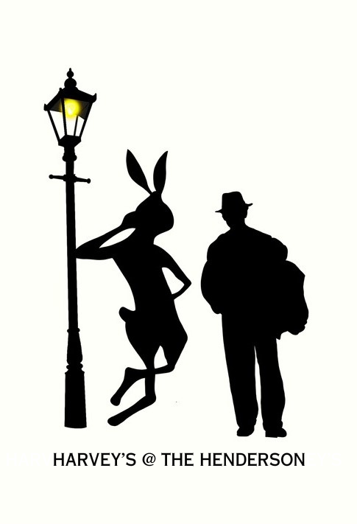

SUNDAY BRUNCH

**COOL & CRISP**

**Buffalo Devilled Eggs**  **12**

Smoke, Sriracha, Blue Cheese Powder

**Panko Crusted Goat Cheese Salad** **16**

Roasted Beets, Cranberries**,** Hazelnut Vinaigrette

**The Henderson Caprese**  ** 14**

Bocconcini, Tomatoes, Herb Oil,

Strawberry-Balsamic Reduction

**Jumbo Shrimp Cocktail 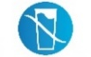 16**

Lemon-Tomato-Horseradish Sauce, Wakame Salad

 Gluten FreeLactose Free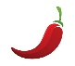 Spicy

 Pescatarian Vegetarian  Vegan

**GFO** Gluten Free Available

* **0A** Vegetarian Option Available

***\*Consuming raw or undercooked meats, poultry, seafood, shellfish, or eggs may increase your risk of foodborne illness***

**SMALL PLATES**

**French Onion Soup 12**

Brioche Crouton, Gruyère Cheese

**Oven Roasted Sea Scallops**  **22**

Lemon & Chive Butter, Toasted Brioche

**Escargots à la Bourguignonne 14 *GFO***

Garlic-Parsley Butter, Toast Points

**NC Shrimp & Crab Crêpes Thermidor**  **18**

Tarragon, Tomatoes, Cognac, Parmesan

**LUNCHY THINGS**

**Traditional British Fish & Chips ** **22**

Beer Battered Cod, Twice Cooked Russet Potatoes, Homemade Tartar Sauce

**Pan Seared NC Mountain Trout**  **22**

Spring Greens, Lemon-Pepper Vinaigrette

**Bœuf Bourgignon  26**

Red Wine, Mushrooms, Pearl Onions,

Roasted Root Vegetables, Mashed Potatoes

**Zucchini ‘Ravioli’**    **20**

Ricotta, Spinach, Basil, Mozzarella Cheese,

Fresh Tomato Sauce

**Salade Niçoise  ** **18*\****

Everything Crusted Ahi Tuna, Egg, Olives

Green Beans, Tomatoes, Sherry Vinaigrette

**BRUNCHY THINGS**

**Smoked Salmon Benedict  18**

Poached Eggs, English Muffin,

Citrus Hollandaise *

**Country Ham & Cheddar Omelet  14**

Potato Hash, Fresh Fruit

**Brioche French Toast 14**

Wild Berry Maple Syrup, House Cured Bacon *******0A***

**Buttermilk Blueberry Pancakes 14**

House Cured Bacon,

Wild Berry Maple Syrup ***0A***

**Smashed Avocado Toast 16**

Scrambled Eggs, Chipotle Aioli, Fresh Fruit, Potato Hash ***GFO***

**Cajun Breakfast Burrito 16**

Scrambled Eggs, Andouille Sausage, Peppers, Cheese, Sour Cream, Salsa

**Caprese Frittata   18**

Buffalo Mozzarella, Teardrop Tomatoes, Basil, Fresh Fruit, Potato Hash