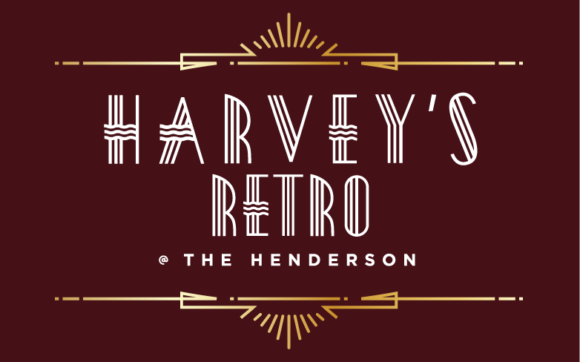

MOTHER’S DAY SUNDAY BRUNCH
APPETIZERS
(Choose One)

French Onion Soup
Brioche Crouton, Gruyère Cheese

Escargots à la Bourguignonne
Garlic-Parsley Butter, Toast Points

Bacon Wrapped Fried Artichoke Hearts
Lemon-Garlic Aioli

Crumbled Goat Cheese Salad 
Roasted Beets, Cranberries, Hazelnut Vinaigrette

The Henderson Caprese
Bocconcini, Tomatoes, Herb Oil,
Strawberry-Balsamic Reduction

Traditional Caesar Salad
Romaine, Shaved Parmesan, Caesar Dressing, Croutons

Jumbo Shrimp Cocktail  
Lemon-Tomato-Horseradish Sauce, Wakame Salad

Gluten FreeLactose Free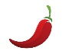 Spicy
 Pescatarian Vegetarian

*Consuming raw or undercooked meats, poultry, seafood, shellfish, or eggs may increase your risk of foodborne illness

LUNCHY & BRUNCHY THINGS (Choose One)
Smoked Salmon Benedict
Poached Eggs, English Muffin, Citrus Hollandaise *

Buttermilk Biscuits & Sausage Gravy
Scrambled Eggs, Potato Hash, Fresh Fruit

Cajun Breakfast Burrito
Andouille Sausage, Scrambled Eggs, Peppers, Cheese, Sour Cream, Salsa

Caprese Frittata
Buffalo Mozzarella, Teardrop Tomatoes, Basil,
Fresh Fruit, Potato Hash

Smashed Avocado Toast
Scrambled Eggs, Chipotle Aioli, Fresh Fruit, Potato Hash

Brioche French Toast
Wild Berry Maple Syrup, House Cured Bacon

Buttermilk Blueberry Pancakes
House Cured Bacon, Wild Berry Maple Syrup

Traditional British Fish & Chips 
Beer Battered Cod, Twice Cooked Russet Potatoes, Homemade Tartar Sauce
Hoisin BBQ Baby Back Ribs
Soba Noodles & Asian Slaw, Tahini Dressing

Free Range Chicken Pot Pie
Baby New Potatoes, Peas, Carrots, Pastry

Zucchini ‘Ravioli’
Ricotta, Spinach, Basil, Mozzarella Cheese,
Fresh Tomato Sauce
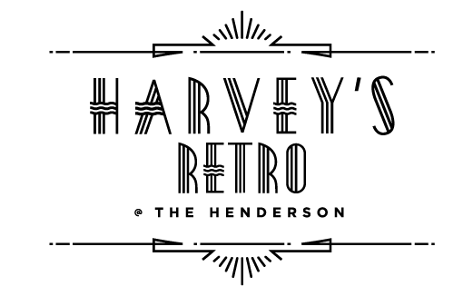
DESSERTS
(Choose One)

SWEET & SINFUL 12

Raspberry Crème Brûlée
Caramelized Sugar

Carrot Cake
Cream Cheese Frosting

Tiramisu
Lady Fingers, Mascarpone, Espresso, Kahlúa

Warm Chocolate Brownie
Vanilla Ice Cream

$49 per person (plus tax & gratuity)



